R Output
> rasp <- read.table("Raspberry.txt",head=T)
> str(rasp)
`data.frame': 16 obs. of 2 variables:
$ water : int 100 100 100 100 200 200 200 200 400 400 ...
$ weight: num 8.1 10.9 11.1 13.9 12.2 11.5 11.4 6.8 6.5 5.5 ...
> rasp$fwater <- factor(rasp$water)
> attach(rasp)
> lm1 <- lm(weight~fwater)
> anova(lm1)
Analysis of Variance Table
Response: weight
Df Sum Sq Mean Sq F value Pr(>F)
fwater 3 115.042 38.347 10.793 0.001004 **
Residuals 12 42.635 3.553

> summary(lm1)
Call: lm(formula = weight ~ fwater)

Coefficients:
Estimate Std. Error t value Pr(>|t|)
(Intercept) 11.0000 0.9425 11.672 6.58e-08 ***
fwater200 -0.5250 1.3328 -0.394 0.70057
fwater400 -5.6250 1.3328 -4.220 0.00119 **
fwater800 -5.6000 1.3328 -4.202 0.00123 **

Residual standard error: 1.885 on 12 degrees of freedom
Multiple R-Squared: 0.7296, Adjusted R-squared: 0.662
F-statistic: 10.79 on 3 and 12 DF, p-value: 0.001004

> plot.means(lm1,xlab="Water Treatment (ml)",ylab="Weight (g)")
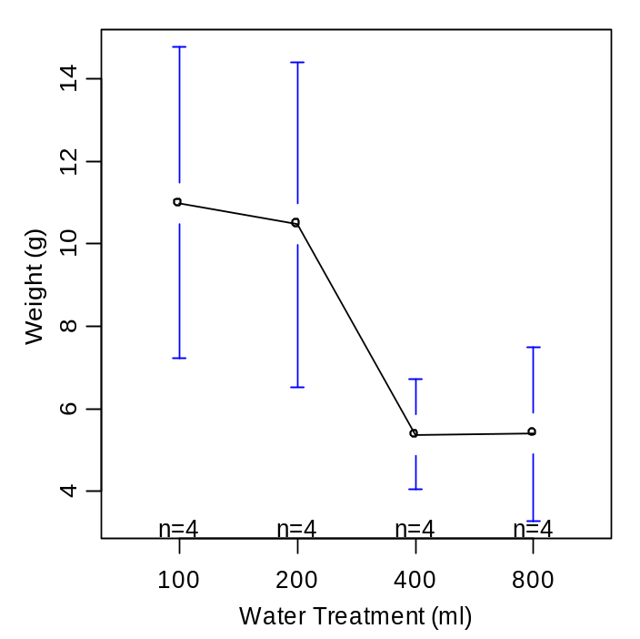

> Levenes(lm1)
Levene's Test for Homogeneity of Variance
Df F value Pr(>F)
group 3 0.3256 0.8069
12

> plot.resid(lm1,loess=F)
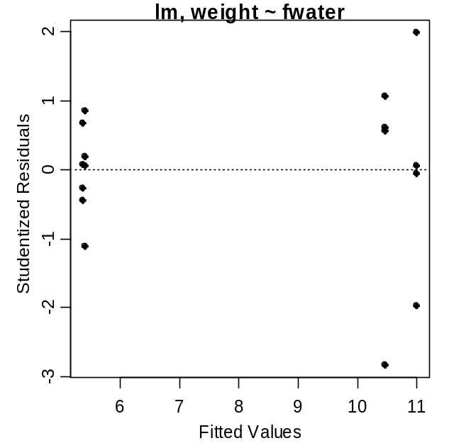
> ad.test(lm1$residuals)
Anderson-Darling normality test
data: lm1$residuals
A = 0.4308, p-value = 0.2688

> hist(lm1$residuals,xlab="Residuals",main="")
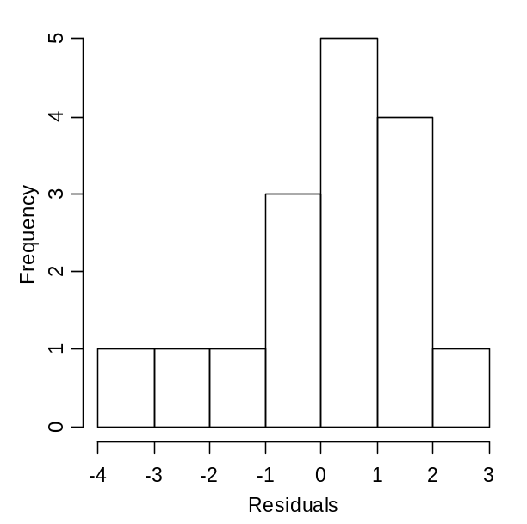
> outlier.test(lm1)
max|rstudent| = 2.836044, degrees of freedom = 11,
unadjusted p = 0.0161961, Bonferroni p = 0.2591376
Observation: 8
> TukeyHSD(lm1)
Tukey multiple comparisons of means
95% family-wise confidence level
Fit: aov(formula = mdl)
$fwater
diff lwr upr p adj
200-100 -0.525 -4.482066 3.432066 0.9783222
400-100 -5.625 -9.582066 -1.667934 0.0056445
800-100 -5.600 -9.557066 -1.642934 0.0058297
400-200 -5.100 -9.057066 -1.142934 0.0111776
800-200 -5.075 -9.032066 -1.117934 0.0115498
800-400 0.025 -3.932066 3.982066 0.9999975

> plot.means(lm1,n.label=F,xlab="Water Treatment (ml)",ylab="Weight (g)")
> add.sig.letters(lm1,lets=c("a","a","b","b"),pos=c(2,4,2,4),
+ col=c("blue","blue","red","red"))
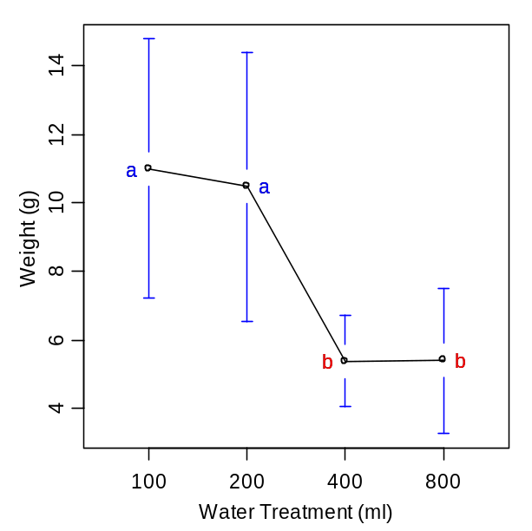
> library(MASS)
> boxcox(lm1,lambda=seq(-1,1.3,0.05))
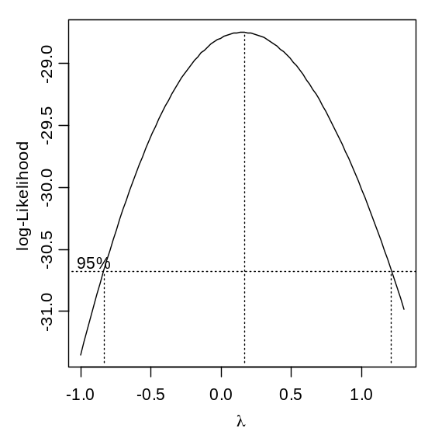

> library(NCStats)
> library(MASS)
> ben <- read.table("BenthicInfaunal.txt",head=T)
> ben$fsite <- factor(ben$site)
> attach(ben)

> lm1 <- lm(abundance~fsite)
> Levenes(lm1)
Levene's Test for Homogeneity of Variance
Df F value Pr(>F)
group 8 3.2452 0.003726 **
63
> plot.resid(lm1,loess=F)
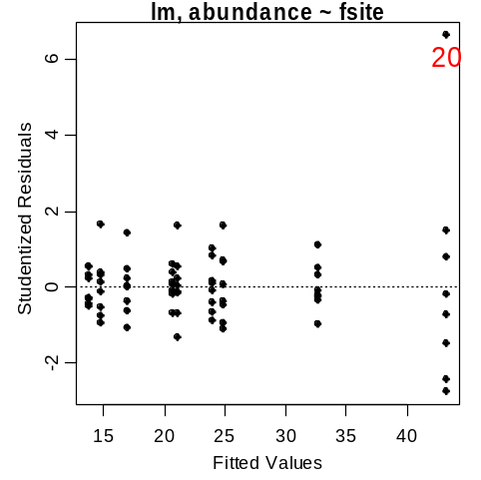

> ad.test(lm1$residuals)
Anderson-Darling normality test
data: lm1$residuals
A = 1.6389, p-value = 0.0002996

> hist(lm1$residuals)
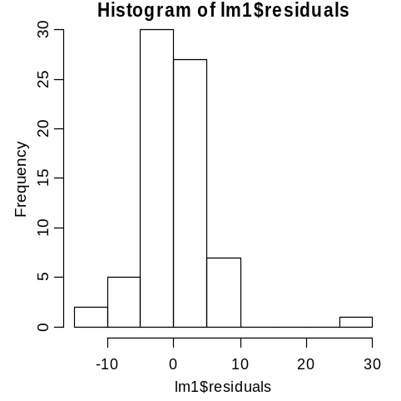

> boxcox(lm1,lambda=c(seq(-0.5,0.5,by=0.05)))

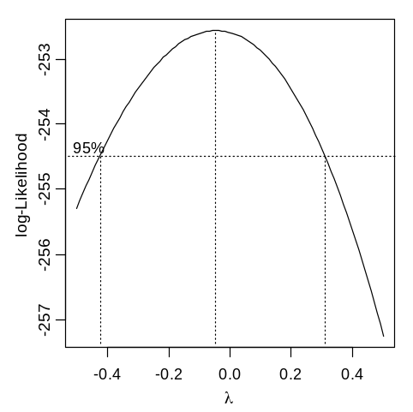
> logab <- log(abundance)
> lm2 <- lm(logab~fsite)
> Levenes(lm2)
Levene's Test for Homogeneity of Variance
Df F value Pr(>F)
group 8 1.5339 0.1636
63
> plot.resid(lm2,loess=F)
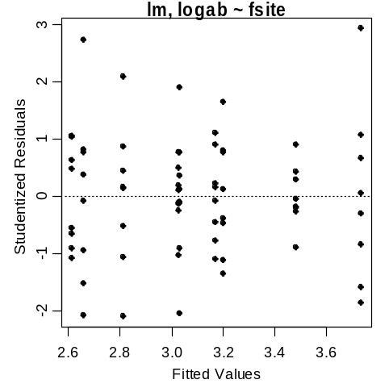
> ad.test(lm2$residuals)
Anderson-Darling normality test
data: lm2$residuals
A = 0.3323, p-value = 0.5062

> outlier.test(lm2)
max|rstudent| = 2.928889, degrees of freedom = 62,
unadjusted p = 0.004753989, Bonferroni p = 0.3422872
Observation: 20

> anova(lm2)
Analysis of Variance Table
Response: logab
Df Sum Sq Mean Sq F value Pr(>F)
fsite 8 8.6683 1.0835 29.066 < 2.2e-16 ***
Residuals 63 2.3485 0.0373

> Dunnett(lm2)
Dunnett's Multiple Comparisons with the 1 level
95% family-wise confidence level

diff lwr upr p adj
fsite2-fsite1 -0.21843454 -0.48184317 0.04497409 1.455690e-01
fsite3-fsite1 0.70318863 0.43978000 0.96659726 2.136258e-08
fsite4-fsite1 0.45383639 0.19042776 0.71724502 1.014194e-04
fsite5-fsite1 -0.41485933 -0.67826796 -0.15145070 4.678606e-04
fsite6-fsite1 -0.00423765 -0.26764628 0.25917098 1.000000e+00
fsite7-fsite1 0.14028047 -0.12312816 0.40368910 5.798012e-01
fsite8-fsite1 -0.37186732 -0.63527595 -0.10845869 1.979583e-03
fsite9-fsite1 0.16866808 -0.09474055 0.43207671 3.796290e-01

> plot.means(lm2,n.label=F,ylab="Log Abundance",xlab="Site")
> add.sig.letters(lm2,lets=c("","","**","**","**","","","**","*"),
+ pos=c(2,4,2,4,2,2,4,2,4))
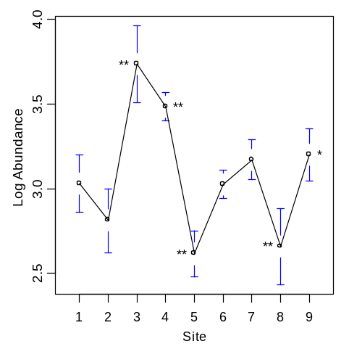
> logdiff <- Dunnett(lm2)
> exp(logdiff[,1:3])
diff lwr upr
fsite2-fsite1 0.8037761 0.6176500 1.0459905
fsite3-fsite1 2.0201841 1.5523809 2.6289577
fsite4-fsite1 1.5743404 1.2097788 2.0487610
fsite5-fsite1 0.6604332 0.5075002 0.8594518
fsite6-fsite1 0.9957713 0.7651859 1.2958426
fsite7-fsite1 1.1505965 0.8841590 1.4973237
fsite8-fsite1 0.6894457 0.5297945 0.8972072
fsite9-fsite1 1.1837272 0.9096178 1.5404382

R Commands

library(NCStats)
rasp <- read.table(“Raspberry.txt”,head=T)
str(rasp)
rasp$fwater <- factor(rasp$water)
attach(rasp)

lm1 <- lm(weight~fwater)
anova(lm1)
summary(lm1)
plot.means(lm1,xlab="Water Treatment (ml)",ylab="Weight (g)")

Levenes(lm1)
plot.resid(lm1,loess=F)
ad.test(lm1$residuals)
hist(lm1$residuals,xlab=”Residuals”,main=””)
outlier.test(lm1)

TukeyHSD(lm1)
plot.means(lm1,n.label=F,xlab="Water Treatment (ml)",ylab="Weight (g)")
add.sig.letters(lm1,lets=c(“a”,”a”,”b”,”b”),pos=c(2,4,2,4),col=c(“blue”,”blue”,”red”,”red”))

library(MASS)
boxcox(lm1,lambda=seq(-1,1.3,0.05))

library(NCStats)
library(MASS)
ben <- read.table("BenthicInfaunal.txt",head=T)
ben$fsite <- factor(ben$site)
attach(ben)

lm1 <- lm(abundance~fsite)
Levenes(lm1)
plot.resid(lm1,loess=F)
ad.test(lm1$residuals)
hist(lm1$residuals)
boxcox(lm1,lambda=c(seq(-0.5,0.5,by=0.05)))

logab <- log(abundance)
lm2 <- lm(logab~fsite)
Levenes(lm2)
plot.resid(lm2,loess=F)
ad.test(lm2$residuals)
outlier.test(lm2)

anova(lm2)
Dunnett(lm2)
plot.means(lm2,ylab=”Log Abundance”,xlab=”Site”)
add.sig.letters(lm2,lets=c("","","**","**","**","","","**","*"),pos=c(2,4,2,4,2,2,4,2,4))

logdiff <- Dunnett(lm2)
exp(logdiff[,1:3])

